Drawing and identifying Science Equipment

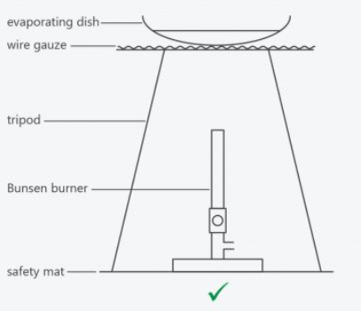Rules for drawing Scientific Equipment:   
1. Always use a _______ and a ______  
2. Draw in __  
3. Always leave glassware _____  
4. Don’t ____ or _________  
5. Label with ______ lines (not _____)

Fill in the blanks as the teacher demonstrates their use.

|  |  |  |
| --- | --- | --- |
| **Equipment name** | **Scientific diagram** | **Safe Use** |
| beaker |  |  |
| conical flask |  |  |
| gauze mat |  |  |
| tripod |  |  |
| Bunsen burner |  |  |
| heatproof mat |  |  |
| filter funnel |  |  |
| measuring cylinder |  |  |

|  |  |  |
| --- | --- | --- |
| evaporating dish |  |  |
| test tube |  |  |
| test tube holder and rack |  |  |
| beaker tongs |  |  |
| spatula |  |  |
| stirring rod |  |  |
| retort stand with boss head and clamp |  |  |
| thermometer |  |  |
| watch glass |  |  |

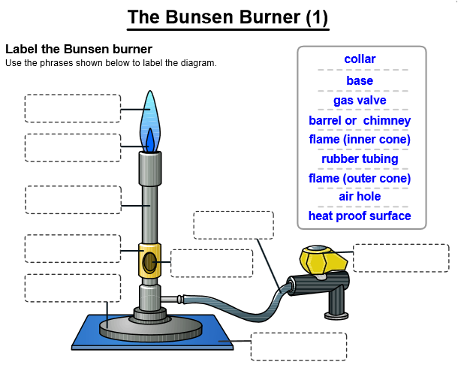

List the steps to safely light a Bunsen Burner:

______________________________________________________________________________________________________________________________________________________________________________________________________________________________________